THE TENTH MID-YEAR SESSION
OF THE
ORIGINAL CAPE FEAR AND SOUTHWESTERN
FREE WILL BAPTIST ANNUAL CONFERENCE

May 16, 2014
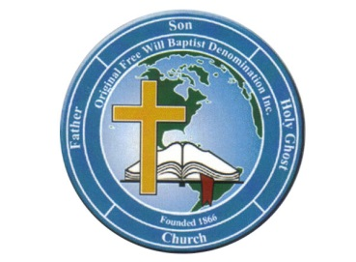

Theme: “I FOUND MY PLACE”
“But now hath God set the members every one of them in the body, as it hath pleased him.” 1 Corinthians 12:18
Convening at
Sidney Grove Church of Deliverance
401 McIntyre Road
Ellerbe, North Carolina 28338
Bishop Arlester Simpson, Pastor

Bishop Reginald S. Hinton, Sr. President
Bishop Frederick E. Clarida, Sr. Vice President
Sister Brenda Williams Secretary
Minister Angela Smith Assistant Secretary
Sister Barbara Harrison Treasurer
Deacon Walter Massey Assistant Treasurer
Sister Phyllis Johnson Parliamentarian
Bishop Henry McLean Bishop Emeritus

THE ORIGINAL CAPE FEAR AND SOUTHWESTERN
FREE WILL BAPTIST ANNUAL CONFERENCE

VISION

We are a Christian Conference sharing fundamental beliefs with a focus on maximizing our collective impact in the world for the Kingdom of God.

MISSION

It is our mission to:
- Support member churches in advancing the cause of Christ
- Promote adherence to the sound biblical beliefs of Original Free Will Baptists
- Train license and ordain ministers within our conference
- Assist member churches in leadership development
- Support vibrant Christian fellowship
- Utilize our collective strengths for the Kingdom of God

THE ORIGINAL CAPE FEAR AND SOUTHWESTERN
FREE WILL BAPTIST ANNUAL CONFERENCE

MID-YEAR SESSION

Friday Evening, May 16, 2014
7:30 p.m.

Order of Service

Praise and Worship Conference Praise Team

8:00 p.m.

Presiding Elder George McIver

Opening Song St. Luke #1 Church Choir

Scripture Elder Theresa Walser

Prayer Elder fred canty

Song St. Luke #1 Church Choir

Welcome Sister Hilda Pemberton

Introduction of the Preacher Bishop Frederick E. Clarida, Sr.

Song St. Luke #1 Church Choir

The Preached Word Elder Kevin Henry

Altar Call Elder Kevin Henry

Conference and Love Offerings Conference Collectors

Announcements Sister brenda williams

Remarks Bishop Frederick E. Clarida, Sr.

Benediction Elder Kevin Henry

