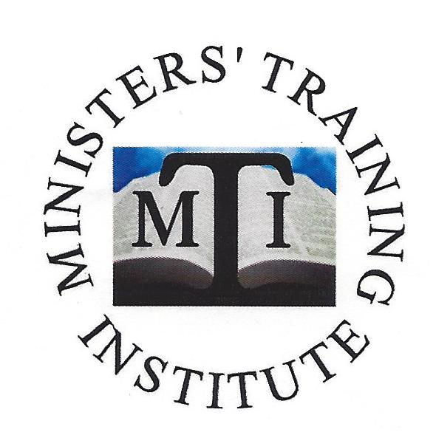
Committed to Excellence
For
God and His People

Fall Semester 2014

Bishop Reginald S. Hinton, D.D.
Presiding Prelate

Bishop Frederick E. Clarida, Sr.
Vice President

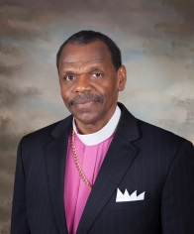
The Original Cape Fear and Southwestern
Free Will Baptist Annual Conference
2801 Mount Pisgah Church Road
Sanford, North Carolina 27332

To my co-laborer in Christ,

Giving honor to God the Father, the Lord Jesus Christ and the Holy Spirit, it is a joy to have the privilege of encouraging you to either continue in or join in our study program established in the Annual Conference to enhance the gifts God has given. We are about to embark upon another semester of study and we would love to have you enrolled.

God continues to bless those that have a hunger and thirst after righteousness and I believe the Ministers’ Training Institute was ordained by God to bless His children. We want to be all that God has called us to be and our time together serves to exhort, inform and prepare us to be even more effective in ministry. The Apostle Paul encouraged his son Timothy to study to show himself approved, a workman that needeth not to be ashamed, but rightly dividing the word of truth. The institute provides a forum for the ministers in our Annual Conference to develop a common understanding of what the word of God teaches.

I beseech you to petition God for His direction regarding the institute and I sincerely believe He will speak to your spirit regarding the importance of the upcoming course of study.

The Lord bless you and keep you in His care.

In His service,

Bishop Reginald S. Hinton
Presiding Prelate

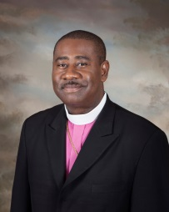
The Original Cape Fear and Southwestern
Free Will Baptist Annual Conference
2801 Mount Pisgah Church Road
Sanford, North Carolina 27332

To all my co-laborers in the ministry,

It is with pleasure that I greet each of you in the wonderful name of our Lord. This is a new year filled with great opportunities for ministry and the Body of Christ. As we continue to face new and changing congregations and audiences in which we minister, there is awareness for additional biblical training.

We are blessed to have the opportunity to obtain that training in our very own conference through the Ministers’ Training Institute. MTI is the vision of our Presiding Prelate, Bishop Reginald S. Hinton. Vision is often the result of need, and there is a need for each of us to continue to grow in the word. The Apostle Paul recognized this truth, as he instructed the young Timothy to “Study to show thyself approved unto God, a workman that needeth not to be ashamed, rightly dividing the word of truth”.

I join Bishop Hinton in encouraging everyone that has been called to preach the word of God to give prayerful consideration to continuing or beginning as a student of MTI. I have personally enjoyed each of the classes I have taken and they have benefited me in pastoral ministry. The material I have acquired continues to serve as a good reference resource. The environment is non-threatening and the fellowship allows for stronger relationships between brothers and sisters.

If I can be of assistance, please contact me. I pray your growth and strength in the Lord.

Bishop Fred Clarida, Sr.
Vice President

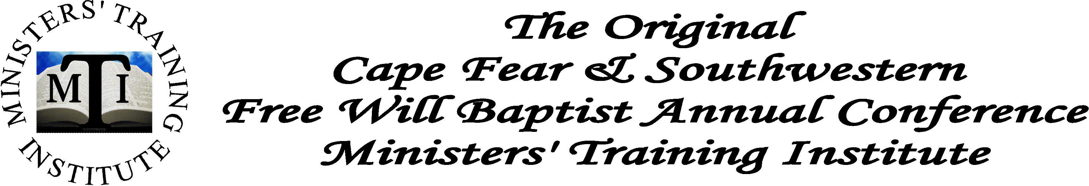

Course Title: Sound Doctrine 1 – 7 Credits
Prerequisite: Ministry Fundamentals
Approximate Length: 14 Sessions

Textbook: See below

Course Objective:

The objective of this course is to examine the basic doctrines of the Christian faith.

The Doctrine of God
The Doctrine of Jesus Christ
The Doctrine of the Holy Spirit
The Doctrine of Man
The Doctrine of Salvation
The Doctrine of the Church
The Doctrine of the Scriptures
The Doctrine of Angels
The Doctrine of Satan
The Doctrine of the Last Things

Class Format:

Students would be expected to exhibit a level of commitment commensurate with this vocation. The class duration would be approximately 2 hours and all students would be expected to complete various homework assignments and projects.

Students will be tested both mid-course and final exams.

A term paper would be required.
Sound Doctrine 1
Course Study
_________________________________

Session One
The Doctrine of God

Session Two
The Doctrine of Jesus Christ

Session Three
The Doctrine of the Holy Spirit

Session Four
Periodic Test 1

Session Five
The Doctrine of Man

Session Six
The Doctrine of Salvation

Session Seven
Mid – Term Exam - Written

Session Eight
The Doctrine of the Church

Session Nine
The Doctrine of the Scriptures

Session Ten
The Doctrine of Angels

Session Eleven
Periodic Test 2

Session Twelve
The Doctrine of Satan

Session Thirteen
The Doctrine of Last Things

Session Fourteen
Final Exam

Sound Doctrine 1
Required Textbook

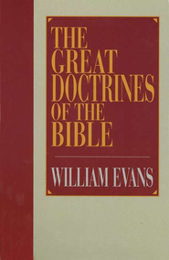

Great Doctrines of the Bible
By: William Evans
Moody Publishers/1995/Hardcover
Bottom of Form

$16.99 (CBD Price)

Sound Doctrine 2
Syllabus

Course Title: Sound Doctrine 2 – 7 Credits
Prerequisite: Sound Doctrine 1
Approximate Length: 12 Sessions

Course Objective:
The objective of this course is to examine the basis for the doctrine of the Cape Fear & Southwestern Free Will Baptist Conference. It is designed to give students the opportunity to examine their convictions about God’s interaction with man as it relates to salvation as well as the basic tenets of Original Free Will Baptist beliefs and organizational structure.

Denominational Doctrine
What is “Free Will”?
Arminianism
Calvinism
Free Will Baptist Doctrine
Free Will Baptist Ordinances
The OFWB Church Covenant
Free Will Baptist Organizational Structure

Class Format:
Students would be expected to exhibit a level of commitment commensurate with this vocation. The class duration would be approximately 2 hours and all students would be expected to actively participate in class discussions, complete various homework assignments and projects.
Students will be tested both mid-course and final.

Term Paper:
A term paper of at least 6 pages, typed, double-spaced using a 12 point Times New Romans font is required. It will include bibliography and footnotes. The term paper should be related to Free Will Baptist doctrine or a related subject or an instructor-approved topic. The term paper is due two weeks prior to the end of the semester.

Sound Doctrine 2
Course Study
_______________________________

Session One
Introduction to Free Will Baptist Doctrine

Session Two
Arminianism and Calvinism

Session Three
Free Will Baptist Doctrine

Session Four
Test 1

Session Five
Free Will Baptist Doctrine
(Term Paper Topic Selected and Approved)

Session Six
Affirmation of Faith

Session Seven
Mid-Term Examination

Session Eight
Free Will Baptist Ordinances

Session Nine
Free Will Baptist Church Covenant

Session Ten
Test 2

Session Eleven
Free Will Baptist Organizational Structure
(Term Paper Due)

Session Twelve
Final Examination

Course Title: Homiletics - 7 Credits

Approximate Length: 13 Sessions

Textbook: See below

Course Objective:

The purpose of this course is to provide the principles for the proper proclamation of the Word of God.

We will examine the following:

What is Homiletics?
- The Topical Sermon
- The Expository Sermon
- The Textual Sermon
- Homiletic Structure
- Preaching Styles
- Sermon Preparation
- Sermon Delivery

Class Format:

Students would be expected to exhibit a level of commitment commensurate with this vocation. The Session duration would be approximately 2 hours and all students would be expected to complete various homework assignments and projects.

Students will be tested both mid-course and final.

Instead of a term paper, students will focus on sermon preparation and delivery.

Homiletics
Course Study

Week One
Introduction to Homiletics

Week Two
Types of Sermons

Week Three
Periodic Test 1

Week Four
Homiletic Structure

Week Five
The Division

Week Six
Mid Term Exam

Week Seven
Student Preaching

Week Eight
The Discussion

Week Nine
The Illustrations

Week Ten
Periodic Test 2

Week Eleven
The Application and Conclusion

Week Twelve
Student Preaching

Week Thirteen
Final Exam

Homiletics
Required Textbook
___________________________________________

Bottom of Form
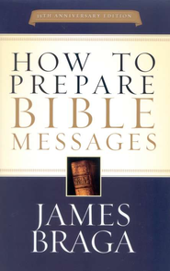

How To Prepare Bible Messages
By James Braga
Multnomah Books / 2005 / Paperback
$11.99 (CBD Price)

Course Title: Old Testament Survey - 7 Credits

Approximate Length: 15 Sessions

Textbook: See below

Course Objective:

The purpose of this course is to provide a survey or overview of the Old Testament. It will include

An introduction to the Old Testament
The Books of the Law
The Books of History
The Books of Poetry
The Books of Prophecy
Survey of the 39 books in the Old Testament.

Class Format:

Students would be expected to exhibit a level of commitment commensurate with this vocation. The Session duration would be approximately 2 hours and all students would be expected to complete various homework assignments and projects.

Students will be tested both mid-course and final exams.

A term paper would be required.

Old Testament Survey
Course Study
____________________________________

Week One
Background

Week Two
Introduction – Chapters 1-3

Week Three
Genesis – Deuteronomy – Chapters 4-9

Week Four
Periodic Test 1

Week Five
Joshua – 1 Samuel – Chapters 10-13

Week Six
2 Samuel – 2 Kings – Chapters 14-18

Week Seven
Mid-term

Week Eight
1 Chronicles – Esther – Chapters 19-23

Week Nine
Job – Psalms – Chapters 24-27

Week Ten
Proverbs – Song of Solomon – Chapters 28-30

Week Eleven
Periodic Test 2

Week Twelve
Chapters 31 – 33

Week Thirteen
Chapters 34 – 36

Week Fourteen
Chapters 37 – 39

Week Fifteen
Final Exam

Old Testament Survey
Required Textbook
___________________________________________
Bottom of Form

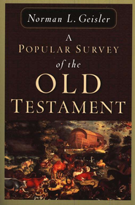

A Popular Survey of the Old Testament
By: Norman L. Geisler
Baker / 1977 / Paperback
$15.49 (CBD Price)

Course Matrix

Below you will find a chart that will assist you in your course selection.

Please select the last course that you have successfully completed from the left hand column . and in the right hand column will be a list of the potenial courses that you may register for.

Please note not every course is offered every semester.

Last Course you successfully completed The Courses you may enroll for
NONE | - Ministry Fundamentals
Ministry Fundamentals | - Sound Doctrine 1
Sound Doctrine 1 | - Sound Doctrine 2  - Church History 1  - Church History 2
Sound Doctrine 2 | - Church History 1  - Church History 2  - Hermeneutics  - Christian Ethics
Church History 1 | - Church History 2  - Hermeneutics  - Christian Ethics
Church History 2 | - Hermeneutics  - Christian Ethics
Hermeneutics | - Homiletics  - Christian Ethics
Homiletics | - Christian Ethics
Christian Counseling Basics | - Christian Counseling II

Admission Instructions

PLEASE RETURN ALL ADMISSION PACKETS BY
August 21, 2014

New Students

- Acquire a letter of reference from your Senior Pastor.

- Please complete the application for admission in its entirety.

- Complete the registration form.

- Please return the completed forms to

E-mail: rhinton5@att.net
Fax: 919-851-5892
Mail: 4801 Waybridge Court, Raleigh, NC 27606

Returning Students

- Complete the registration form.

- Please return the completed forms to

E-mail: rhinton5@att.net
Fax: 919-851-5892
Mail: 4801 Waybridge Court, Raleigh, NC 27606

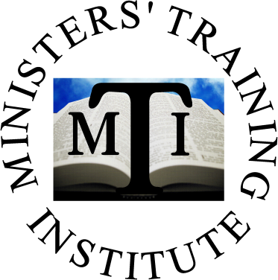
The Original
Cape Fear & Southwestern
Free Will Baptist Annual Conference
Ministers' Training Institute

APPLICATION FOR ADMISSION
OFFICE USE ONLY

DATE RECEIVED_____________________

DATE PROCESSED____________________

STUDENT ID NO. _____________________

PLEASE RETURN COMPLETED
APPLICATION TO

Preferred Methods
E-mail: rhinton5@att.net
FAX: 919-851-5892

If you are unable to email or fax the information you may mail it to:
4801 Waybridge Court
Raleigh, NC 27606

This application should be completed in detail. Please use N/A if any question is NOT APPLICABLE

PERSONAL INFORMATION

NAME ________________________________________________________________________________
LAST FIRST MIDDLE

BIRTH DATE ___ / ___ / ___ AGE _______ GENDER  MALE  FEMALE

HOME ADDRESS ______________________________________________________________________
STREET CITY ST ZIP COUNTY

MAILING ADDRESS ___________________________________________________________________
STREET CITY ST ZIP COUNTY

HOME PHONE (______ ) _____________________ CELL (_______) _______________________

EMAIL ADDRESS ______________________________________________________________________

CHRISTIAN EXPERIENCE

***A Letter of Reference from your Pastor must be submitted with this application.

Current Church Affiliation ________________________________________________________________

PASTOR ______________________________________________________________________________

How long have you been a member of the above named Church? ____________________

Current Ministerial Status  Ministerial Candidate  Minister  Ordained Elder  Pastoring Elder

How long have you been saved? __________ Year that you were called into the Ministry ___________

THE ORIGINAL
CAPE FEAR & SOUTHWESTERN
FREE WILL BAPTIST
ANNUAL CONFERENCE
MINISTERS’ TRAINING INSTITUTE
APPLICATION FOR ADMISSION
Page 2

CHRISTIAN EXPERIENCE-continued

Previous Church Affiliation ________________________________________________________________

Church Address _________________________________________________________________________
STREET CITY ST ZIP

Church Telephone (______) _____________________________

Previous Pastor __________________________________________________________________________

Denominational Affiliation of Previous Church ________________________________________________

Length of your membership in the above named church __________________

EDUCATIONAL BACKGROUND

SECULAR STUDIES

HIGH SCHOOL ATTENDED ________________________________ GRADUATION DATE _____________

COLLEGE ATTENDED _____________________________________GRADUATION DATE _____________

DEGREE(S) RECEIVED __________________________________________________________________

THEOLOGICAL STUDIES

SCHOOL ATTENDED ____________________________________________________________________

DEGREE(S) RECEIVED __________________________________________________________________

I ___________________________________________, do hereby request admission to the Original Cape Fear & Southwestern Free Will Baptist Annual Conference Ministers’ Training Institute. It is my desire to give God my best: therefore it is with a sober minded commitment that I do hereby state that I will make every effort to show myself a workman unto God rightly dividing the word of truth.

________________________________________________________ ________________________
SIGNATURE DATE

The Original
Cape Fear & Southwestern
Free Will Baptist Annual Conference
Ministers' Training Institute

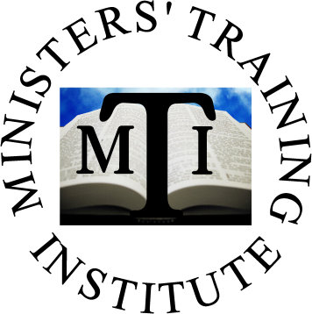

REGISTRATION FORM

NAME: _____________________________________________

Telephone: ______________________________ Cell: ___________________________

Email: _____________________________________________________

Please find below a listing of the classes currently being offered, we ask that you indicate the class that you wish to attend.

COURSES OFFERED

Course Title: Sound Doctrine 1  Instructor: Elder Wayne McKoy  Location: Star of Hope  Course Duration: 14 Sessions  Class Frequency: Weekly every Saturday @ 9:00AM  Class Duration: 2 Hours  Course Start Date: September 6, 2014  Please enroll me in this class _____ | Course Title: Sound Doctrine 2  Instructor: TBD  Location: Star of Hope  Course Duration: 12 Sessions  Class Frequency: Weekly every Saturday @ 9:00AM  Class Duration: 2 Hours  Course Start Date: September 6, 2014  Please enroll me in this class _____
Course Title: Homiletics  Instructor: Bishop Reginald Hinton  Location: Star of Hope  Course Duration: 13 Sessions  Class Frequency: Weekly every Saturday @ 9:00AM  Class Duration: 2 Hours  Course Start Date: September 6, 2014  Please enroll me in this class _____ | Course Title: Old Testament Survey  Instructor: Elder David Jones  Location: Mount Pisgah Harnett  Course Duration: 15 Sessions  Class Frequency: Weekly every Thursday @ 7:00PM  Class Duration: 2 Hours  Course Start Date: September 4, 2014  Please enroll me in this class _____

***Please Note - Enrollment in all classes is on a first come / first served basis.

**For new students
This registration form will not be accepted without a completed Application for Admission.

